**Residency and activity space of white sharks (*Carcharodon carcharias*) and yellowtail kingfish (*Seriola lalandi*) in response to reduce wildlife tourism during COVID-19 restrictions**

*Charlie Huveneers, Vinay Udyawer, Thomas Clarke*

**Background**

The white shark cage-diving industry began in the late 1970s in waters off the Eyre Peninsula in South Australia. The industry has been restricted to the Neptune Islands Group Marine Park located 60–70 km south of Port Lincoln since 2002, with most cage-diving activities focussed at the North Neptune Island group. The locality is the only place where cage-diving with white sharks is permitted in Australia. After 2007, the industry expanded from two to three operators and the mean annual number of days when tours operated rose from 124 (2000–2006) to 265 (2008–2011) (Bruce and Bradford 2013). Due to concern over the potential impact of the cage-diving industry on white sharks, the number of days operators are allowed at the Neptune Islands group has been limited since 2012, with operators only allowed to run trips on 10–12 days per fortnight. Over the years, operators have used the Neptune Islands relatively consistently and operated throughout the year on 227–280 days of the year (mean 256.75 ± 7.02 days; 2012–2019; Fig. XX). However, the COVID-19 restrictions imposed on the 22nd of March 2020 led to operators being unable to take tourists and to the industry to effectively shut down until restrictions were lifted on the 12th of May 2020. As a result, no boat visited the Neptune Islands for 51 days, the longest period of industry inactivity for over 10 years.

**Methods**

*Receiver deployments and tagging*

Three VR2AR acoustic receivers (Innovasea Ltd., Halifax, Canada) have been deployed since July 2016 using a low-profile sub-surface mooring system. One VR2AR was deployed at each of the main berleying sites at the North Neptune Islands group and one at the South Neptune Islands group. In 2018, a fine-scale positioning system (VPS Vemco Positioning System) consisting of an additional array of 13 VR2AR receivers were deployed, and expanded the acoustic coverage at the North Neptune Island.

Since 2013, 130 white sharks were externally tagged with V16-6H tags (Innovasea Ltd., Halifax, Canada) as part of the South Australian cage-diving industry monitoring program. Tags were tethered to a Domeier umbrella dart-tag head using a 10- to 15-cm-long stainless wire trace (1.6 mm diameter) and implanted in the dorsal musculature of sharks using a modified spear-gun applicator. Biases in residency estimates can be introduced by targeting specific sharks (e.g., sharks likely to remain in the Neptune Islands) or due to temporal variations in residency (e.g., sharks are more likely to remain within Neptune Islands during weaning of New Zealand fur seals). To minimise the potential impacts of these biases, tags were opportunistically deployed throughout the year.

Sixteen yellowtail kingfish (*Seriola lalandi*) were acoustically tagged between August 2018 and May 2019. Fish were caught using handline and put onto a paddle cradle. Seawater was circulated across the gills using a water pump to ensure continuous oxygenation during handling. A small incision (1.5–2 cm) was made along the central line of the ventral surface, anterior of the pelvic fins. A with V13A or V16A tag was inserted into the body cavity. The incision was stitched using 2–3 non-continuous external sutures (3/0 Monosyn absorb violet 70 cm, needle tapercut). A plastic head conventional identification tag (Hallprint™, Hindmarsh Valley, South Australia) was inserted into the muscle below the first dorsal fin to identify in the event of a recapture. The stretched total length (TL) of each fish was measured to the nearest centimetre prior to releasing the fish.

*Residency and space use estimates*

For each tagged shark and fish, the number of consecutive days that individuals were present was calculated each time they entered the study area. A residency period was defined as the number of days between the first and last detection of a tagged shark, without any gaps in consecutive days of detection exceeding 5 days. A five-day period was selected on the basis of estimated transit times between the North and South Neptune Islands (1). Where sharks were not detected over periods of >5 consecutive days, individuals were assumed to have left the Neptune Islands and any subsequent return was considered to represent a new residency period. The residency of white sharks is reported for the COVID-19 restriction period from the 23rd of March until the 16th of May 2020 and compared across years of monitoring (2017–2020).

Weekly residency and activity space was estimated for March–May 2020 for each white shark and yellowtail kingfish. Residency index is the number of days a tag is detected divided by the total number of days it could be detected (i.e. seven days for each weekly subset). Centre of activities (COA; 2) were estimated to calculate activity space metrics using a Brownian Bridge movement model (henceforth BB-KUD). Both the residency index and BB-KUD were calculated using the ATT functions within the VTrack package (3).

We tested the effects of COVID-19 restrictions on the residency period, residency index, and activity space using a Generalised Linear Mixed-Model (GLMM) with tag ID as the ‘random effect’ and the lmer or lme function in the lme4 package (4). The error structure of GLMM corrects for non-independence of statistical units due to shared temporal structure and permits the random effects variance explained at different levels of clustering to be decomposed. The inclusion of tag ID as a random effect enabled the analysis to account for the lack of independence in behaviour within each tagged shark and fish. We accounted for temporal autocorrelation for the residency index and activity space by using the lme function instead of lmer and including a correlation factor (i.e. week) in the models. The most appropriate transformation, statistical family, error distribution, and validity of the model were determined through an examination of the distribution of the response variable and a visual inspection of the residuals for the saturated models.

**Results**

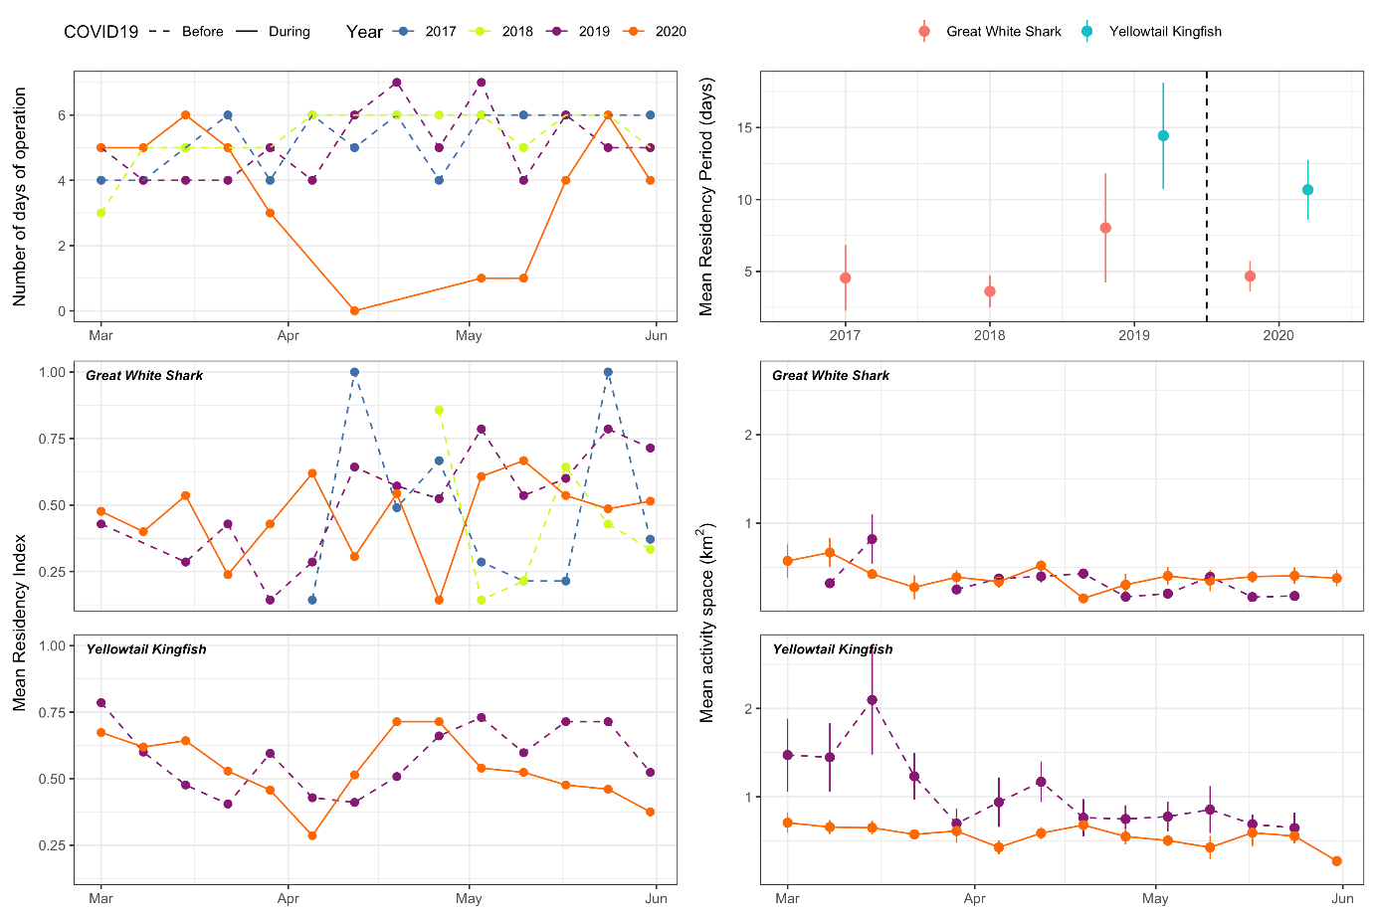

|  |  |  |  |  |  |  |
| --- | --- | --- | --- | --- | --- | --- |
| Table 1. Generalised Linear Mixed-Model (GLMM) results showing the effects of COVID-19 restrictions on white shark (*Carcharodon carcharias*) and yellowtail kingfish (Seriola lalandi) residency index and activity space. SE = standard error; CI = confidence interval; df = degree of freedom | | | | | | |
| **Parameter** | **Coefficient** | **SE** | **95% CI** | **t-value** | **df** | **P-value** |
| *White shark (residency period)* | |  |  |  |  |  |
| Intercept | 0.90 | 0.49 | -0.07,1.86 | 1.82 | 40 | 0.069 |
| COVID vs pre-COVID | -0.58 | 0.63 | -1.82,0.65 | -0.93 | 40 | 0.354 |
| *Yellowtail kingfish (residency period)* | | |  |  |  |  |
| Intercept | 3.03 | 0.47 | 2.11,3.95 | 6.43 | 50 | <0.001 |
| COVID vs pre-COVID | 0.26 | 0.57 | -0.86,1.38 | 0.45 | 50 | 0.653 |
| *White shark (residency index)* | |  |  |  |  |  |
| Intercept | 0.27 | 0.15 | -0.04,0.57 | 1.75 | 77 | 0.083 |
| Week | 0.01 | 0.01 | -0.01,0.03 | 1.19 | 77 | 0.239 |
| Year (2017) | 0.41 | 0.37 | -0.32,1,14 | 1.11 | 77 | 0.27 |
| Year (2018) | -0.04 | 0.92 | -1.88,1.80 | -0.05 | 77 | 0.962 |
| Year (2019) | -0.27 | 0.32 | -0.91,0.37 | -0.85 | 77 | 0.397 |
| week * year (2017) | -0.03 | 0.02 | -0.07,0.02 | -1.25 | 77 | 0.217 |
| week * year (2018) | 0.00 | 0.05 | -0.09,0.09 | -0.03 | 77 | 0.978 |
| week * year (2019) | 0.02 | 0.02 | -0.02,0.05 | 0.99 | 77 | 0.325 |
| *Yellowtail kingfish (residency index)* | | |  |  |  |  |
| Intercept | 0.71 | 0.1 | 0.52,0.91 | 7.26 | 207 | <0.001 |
| Week | -0.01 | 0.01 | -0.02,0.00 | -2.11 | 207 | 0.036 |
| Year (2019) | -0.18 | 0.15 | -0.47,0.11 | -1.22 | 207 | 0.226 |
| week * year (2019) | 0.01 | 0.01 | 0.00,0.03 | 1.58 | 207 | 0.116 |
| *White shark (activity space)* | |  |  |  |  |  |
| Intercept | 0.63 | 0.12 | 0.41,0.86 | 5.48 | 62 | <0.001 |
| Week | -0.01 | 0.01 | -0.02,0.00 | -1.60 | 62 | 0.109 |
| Year (2019) | 0.02 | 0.24 | -0.45,0.50 | 0.09 | 62 | 0.925 |
| week * year (2019) | -0.01 | 0.01 | -0.03,0.02 | -0.50 | 62 | 0.619 |
| *Yellowtail kingfish (activity space)* | |  |  |  |  |  |
| Intercept | 0.78 | 0.1 | 0.58,0.99 | -1.99 | 279 | <0.001 |
| Week | 0.00 | 0.01 | -0.01,0.01 | -3.61 | 279 | 0.931 |
| Year (2019) | 0.32 | 0.12 | 0.08,0.56 | -1.36 | 279 | 0.01 |
| week * year (2019) | -0.02 | 0.01 | -0.03,-0.01 | 0.58 | 279 | 0.007 |

**Model formula**

mod1 <- lmer(log(residency_days) ~ covid + (1|tag_id), data = shark_res)

mod2 <- lmer(sqrt(residency_days) ~ covid + (1|tag_id), data = king_res)

mod3 <- lme(res_index ~ week * year, random = ~1|transmitter, data = shark_res_weekly,

correlation = corAR1(form= ~1|transmitter/week))

mod4 <- lme(res_index ~ week * year, random = ~1|transmitter, data = king_res_weekly,

correlation = corAR1(form= ~1|transmitter/week))

mod5 <- lmer(hr ~ week * year + (1|tag_id), data = shark_hr_weekly)

mod6 <- lmer(sqrt(hr) ~ week * year + (1|tag_id), data = king_hr_weekly)

**References**

1. Bruce BD, Bradford RW. The effects of shark cage-diving operations on the behaviour and movements of white sharks, *Carcharodon carcharias*, at the Neptune Islands, South Australia. Mar Biol. 2013;160:889–907.

2. Simpfendorfer CA, Heupel MR, Hueter RE. Estimation of short-term centers of activity from an array of omnidirectional hydrophones and its use in studying animal movements. Can J Fish Aquat Sci. 2002;59:23-32.

3. Udyawer V, Dwyer RG, Hoenner X, Babcock RC, Brodie S, Campbell HA, et al. A standardised framework for analysing animal detections from automated tracking arrays. Animal Biotelemetry. 2018;6(1):17.

4. Bates D, Mächler M, Bolker B, Walker SJapa. Fitting linear mixed-effects models using lme4. 2014.